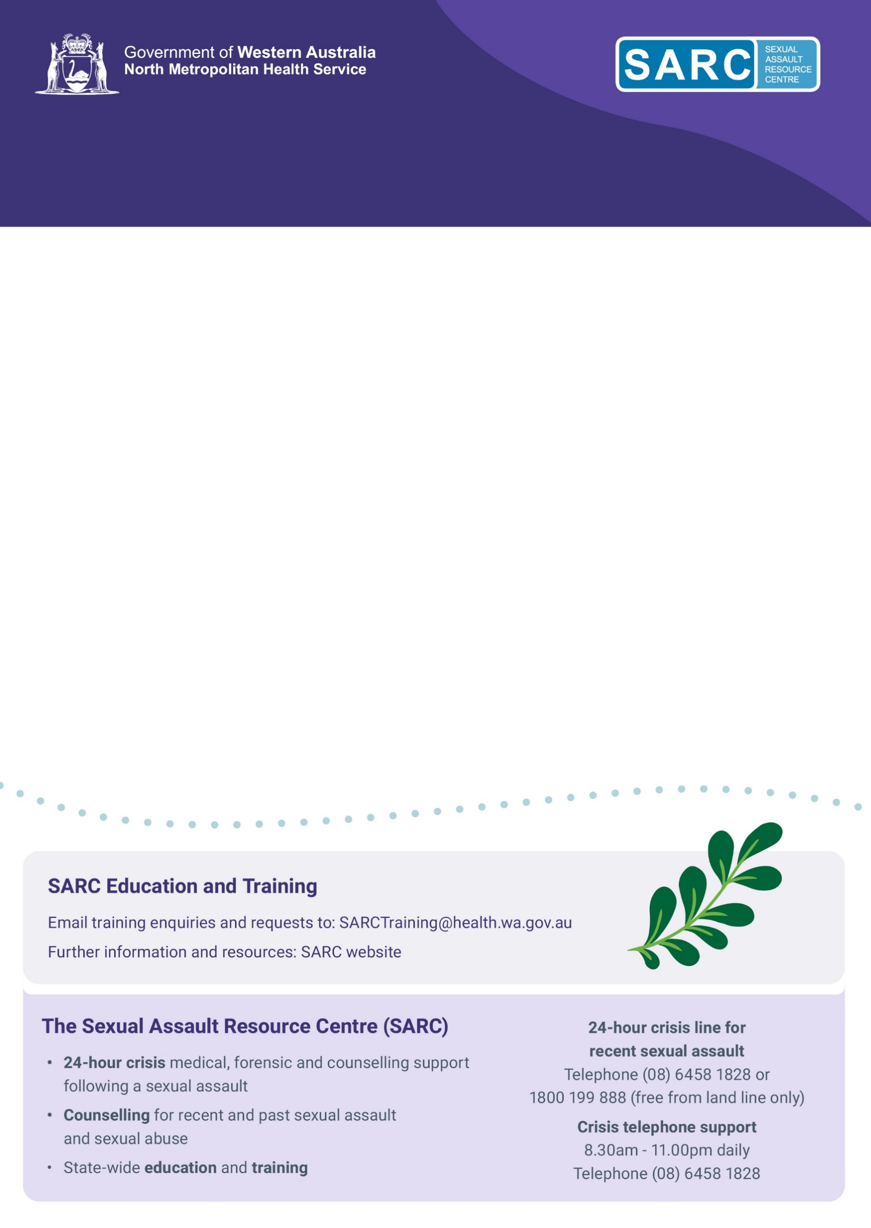**This WA Health training programme addresses how to respond to recent sexual assault in adolescents and adults. It will provide the knowledge and basic skills required to provide relevant medical care, conduct a forensic examination, and collect appropriate forensic specimens for these patients.**

**EOI: SARC Forensic Training Program**

**For Doctors, RNs and Midwives working outside WACHS**

**The course is designed for Registered Nurses, Midwives and Doctors working in regional areas (or intending to do so in the near future).**

**Course Information**

* Courses will be offered in Perth and regional areas each year.
* Delivered by experienced SARC doctors.
* There is required e-learning to be completed prior to the course.
* Doctors, Midwives and Registered Nurses are eligible to enrol.
* This is an opportunity for doctors to upskill in this area.
* Participants must complete the full 3 days; and assessments will be conducted.
* Nurses and Midwives who successfully complete the course will be qualified to collect forensic specimens from patients who have been sexually assaulted, as approved by WA legislation, Criminal Investigation Act Amendment 2011.
* A course overview is available on the [SARC website](https://www.kemh.health.wa.gov.au/For-Health-Professionals/SARC/Medical-education).
* **Content in this course can be triggering for people affected by sexual trauma.**

|  |  |
| --- | --- |
|  |  |

**Applicant details** (non-WACHS employee)

|  |  |  |  |
| --- | --- | --- | --- |
| **Name:** |  | | |
| **Job role:** |  | | |
| **Organisation/ hospital:** |  | | |
| **Email address:** |  | | |
| **Comments:** |  |  |  |
| Please return your completed Expression of Interest to [SARCTraining@health.wa.gov.au](mailto:SARCTraining@health.wa.gov.au) and state in the Subject line: ‘EOI FTP’. | | | |